**4.2 three-color electronic label image encoding format**

**Revision History**

|  |  |  |  |
| --- | --- | --- | --- |
| **Version** | **Date** | **Change Description** | **Author** |
| V1.0 | 2018/9/3 | Init version | Ning |
|  |  |  |  |
|  |  |  |  |
|  |  |  |  |
|  |  |  |  |
|  |  |  |  |
|  |  |  |  |
|  |  |  |  |

**C O N F I D E N T I A L**

. **Catalogue**

1. Purpose 3

2. Label 4.2 inch image encoding format 3

3. Appendix 4

# Purpose

This article describes the 4.2inch electronic tag image encoding format, which is used to guide third parties to develop images that use the program to generate tags.

# Label 4.2 inch image encoding format

The display of the 4.2-inch electronic label is displayed from left to right and from top to bottom.

The 4.2-inch electronic tag has a resolution of 400*300, which is equivalent to 120,000 pixels. Each pixel adopts three-color display, corresponding to binary 00(black) , 01(white) and 10(red),. If byte encoding is used, it is equivalent to 1 byte and can represent 4 pixels. That is, it can be represented by 120,000/4=30 000 bytes.

When the cloud initiates an image update to an electronic tag, it needs to send 30000 bytes. Since JSON encoding is used, hexadecimal bytes are required in ASCII, so 1 byte corresponds to 2 ASCII, which is equivalent to 30000*2 ASCII characters for one picture. So we suggestion using compression coding, which can greatly reduce the number of characters.

The following examples illustrate:

Example 1: If we want do the following display



1) Display 1 red dot on the far left (upper left corner) of the 1st line, then 1 white point, then 1 black dot;

2) Display 1 black dot in the third pixel of the 1st line.

3) Display 1 black dot at the end of 1 st line.

4) Display 1 black dot on the far left of the 2nd line.

The corresponding code is as follows:

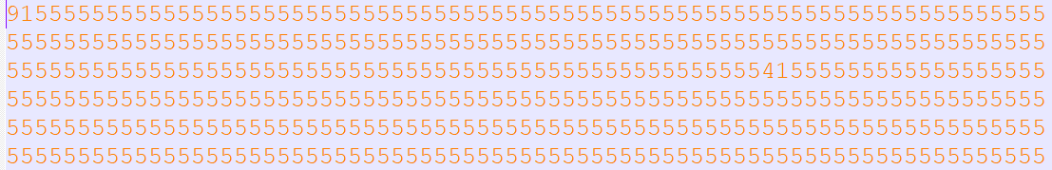

For 4.2 inch three color ESL, one row need 100byte (400 pixels).

First line:

* the first byte was 0x91: Corresponding binary digits: 1001 0001, it means first pixel was red(10), the second pixel was black(01) and the third pixel was black(00).
* The last byte was 0x54:

Second line:

* The first byte was 0x15:

# Appendix

1. We also attach a file "4.2inchExample_3color.bmp" file in the directory, and we also provide the mqtt message that include image content (4.2inchExample_3color.bmp.json).

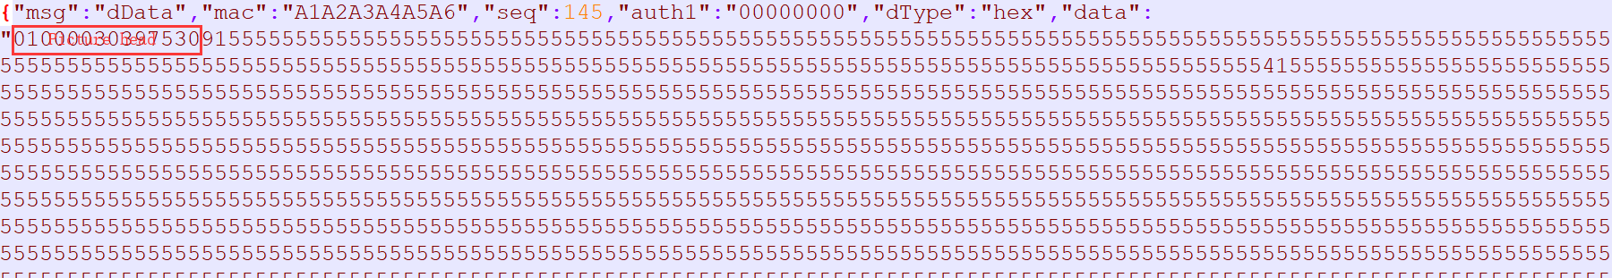

2. We also attach a file “4.2inchExample.bmpz.json” in the same directory. This file was compression encoding. You can see that the file size is very small. We recommend using compressing encoding json message for 4.2inch ESL when sending picture to ESL.